

Automotive Vinyl Graphics

The Automotive Illustrators

MRKT 371 – Personal Selling

Kyle Edington

February 2009

Table of Contents

A Letter from the President: 4

Mission Statement: 5

Company Policies 6

General Policies 6

Payroll Policies 7

Legal Issues 8

Ethical Issues 8

Company Description 9

Competitor Profiles 11

Product/Service 13

Promotion 16

Placement 17

Description of Features 18

Immediate Consumer 18

Ultimate Customer 19

Description of Typical Prospects 20

Immediate Consumers 20

Ultimate Consumers: 20

Reasons For Buying 21

Maslow’s Hierarchy of Needs 22

PRESALE PLAN 24

Prospect Analysis 24

What Will You Do 24

What Will You Say 24

Social Style Matrix 25

The Sale Presentation 27

Sample Questions which Help in Identifying Needs of Customer 27

Major Appeals 27

Outline of Sales Presentation 28

The Sales Demonstration 30

Demonstration Analysis Form 30

Selling aids you will use 30

Additional Assistance 35

Long-term partnering plan 36

Territory management plan 36

Glossary 36

Appendix 37

# A Letter from the President:

Dear Valued Employee,

Congratulations and welcome to the Automotive Illustrators. We are thrilled to have you join our company, and aid us in completing our mission. As our newest Sales Leader, your role is critical to expanding our operations.

Over the next few weeks, we will invest our resources to train and orient you to the company and our industry. It was very clear, from the initial interview that you have enormous potential, and that is why, the time we will take to train you is very important in helping you reach that potential. You will need to refer often to the written information you will receive within this manual. Please feel free to contact your supervisor or my secretary to speak with me personally, if any questions or issues develop.

We are looking forward to establishing a fruitful relationship here with The Automotive Illustrators.

Sincerely,

Jonathan T. Applegate

President, The Automotive Illustrators

The New Corporate office of The Automotive Illustrators

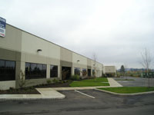

# Mission Statement:

“The Automotive Illustrators mission is to establish our firm as an industry leader in vinyl wraps for automobiles. Using the highest quality processes, including vinyl products, inks, and laminate, we pass along our quality products to other firms in order to expand their product offerings.”

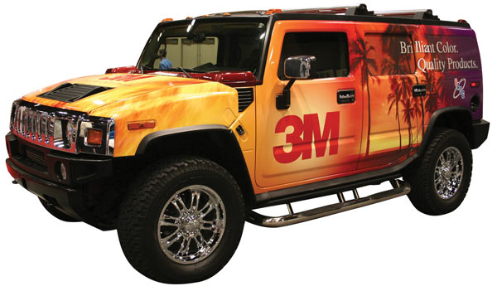

# Company Policies

### General Policies

Personnel Records:

To ensure that The Automotive Illustrators’ personnel records are accurate at all times, we request that the employee promptly notifies The Automotive Illustrators’ Human Resource Department for changes in names, home address, marital status, number of dependants, telephone number or any other information that an employer should be made aware of a change.

Attendance:

As an employee of The Automotive Illustrators, you are expected to arrive to work before your scheduled start time and be engaged in productive The Automotive Illustrators work at the start of your scheduled time. All time off must be approved of in advance, see vacation time and sick leave.

Attendance is taken very seriously at The Automotive Illustrators and will be an importance facet of your quarterly performance review. Each absence will be documented and excessive absences will result in disciplinary action, up to and including termination.

Use of Company Property:

The Automotive Illustrators provides you with the necessary equipment to do your job, this equipment will not be used for personal use, nor removed from The Automotive Illustrators unless it is approved and your job specifically requires use of company equipment.

Company laptops are not to be used for personal use. It is forbidden to install any other programs to a company computer without the written permission of your supervisor. These forbidden programs include, but are not limited to, unlicensed software, pirated music, and pornography. The copying of programs installed on the company computers is not allowed unless you are specifically directed to do so in writing by your supervisor.

The telephone lines at The Automotive Illustrators must remain open for business calls to service our customers. Employees are requested to discourage personal calls - incoming and outgoing - with the exception of emergency calls. Company provided cell phones are to be used strictly for company business. No long distance calls, which are not strictly business-related, are to be made on any company phones.

Dress Code:

The Automotive Illustrators employees are expected to present a clean and professional appearance when representing the company. Standard protocol requires Suits on any meetings with potential clients. Company polo’s and kakis are allowed on Fridays, unless your supervisor specifically instructs you otherwise. Earrings are only to be worn by female employees and limited to 2 piercings located on your ears.

Safety:

In accordance with the Occupational Safety and Health Act of 1970, The Automotive Illustrators provides a clean, hazard free, healthy environment in which to work. Employees are expected to actively maintain this environment by observing posted safety rules and use proper safety equipment. Any safety problems must be reported to your supervisor immediately. For work related injury, see Worker’s Compensation.

Substance Abuse:

The Automotive Illustrators’ commitment to providing a substance free environment has a no toleration substance policy. Employees are not allowed to consume, purchase, or be under the influence of substances while on company time. Employees who fail to meet this requirement will be terminated.

Smoking:

In order to provide a healthy working environment The Automotive Illustrators does not allow smoking within 15 feet of company entranceways or in company vehicles.

### Payroll Policies

Holidays:

The Automotive Illustrators recognizes the following holidays: New Years Day, Martin Luther King Day, Independence Day, Thanksgiving, and Christmas.

Full-time employees will be fully compensated (8 hours pay) for those days that The Automotive Illustrators recognizes as holidays. If a holiday falls on a weekend then The Automotive Illustrators will observe that holiday on the following Monday.

Vacation Time:

Only full-time employees of The Automotive Illustrators are eligible for paid vacation time after one full year of employment. Beginning in the second year, 7 days vacation will be allotted. Every following year of employment, 2 days will be added. Up to 4 days of vacation time may be rolled over into a following year.

In order for The Automotive Illustrators to accommodate vacation request you must submit a written vacation application at least 2 weeks prior to assure that The Automotive Illustrators can prepare for your absence. The Automotive Illustrators will do everything possible to allow the requested days to be granted; however, please note that in some situations vacation time may not be granted.

Sick Leave:

The Automotive Illustrators employees are eligible for sick leave. Sick leave will be accrued at the rate of a half (1/2) day per month of employment up to six (6) days a year. Any employee that is unable to work longer than two (2) consecutive days is required to provide a doctor’s certificate stating the nature of the illness.

This policy does not apply to those illnesses of injuries that are covered by the worker’s compensation policy, see workers compensation.

Maternity Leave:

The Automotive Illustrators employees are allowed up to five (5) weeks of leave after they give birth to or adopt a child. The employee will be paid at 60% their regular salary during this time

Jury Duty:

The Automotive Illustrators supports employees who are called to serve jury duty. You will be granted full salary for a maximum of two (2) weeks. You must submit a copy of your jury summons as soon as possible to your superior. If you are released for jury duty and can fulfill a half day (4 hours), you are required to return to work.

Workman’s Compensation:

The Automotive Illustrators Workman’s Compensation Insurance covers employees injured on the job. It is the employee’s responsibility to notify the supervisor immediately of injuries that are sustained. We encourage injured employees to seek immediate medical attention. You will be contacted by a representative of the insurance company and personnel representative.

### Legal Issues

Sexual Harassment:

The Automotive Illustrators will not tolerate and take legal action against employees involved in sexual harassment. Sexual Harassment is defined as:

* Making submission to unwelcome sexual advances or requests for sexual favors a term or condition of employment
* Basing an employment decision on submission or rejection by an employee of unwelcome sexual advances, requests for sexual favors or verbal or physical contact of a sexual nature
* Creating an intimidating, hostile or offensive working environment or atmosphere either by:

a) Verbal actions, including calling employees by terms of endearment; using vulgar, kidding or demeaning language; or

b) Physical conduct, which interferes with an employee's work performance.

### Ethical Issues

Ethics is the set of rules or standards that govern the conduct of a person or members of a profession. In addition, ethics is also an individuals’ awareness of right and wrong. We expect not only our sales team, but also every Illustrator, to display proper judgment when representing our team.

For a more detailed ethics guide, feel free to contact your supervisor or check out the Specialty Graphic Imaging Association website – [www.sgia.org](http://www.sgia.org)

Pre-Approach Information

## Company Description

At The Automotive Illustrators, we specialize in the creation and printing of high quality vinyl graphics used specifically for enhancing the design and appearance of vehicles used by companies and individuals on the road. At the Automotive Illustrators, we are responsible for aiding in design, printing the vinyl, and delivering our superior product to clients across the nation.

Utilizing our skill to create quality automotive wrap, we sell our products to custom car shops and other printing outlets, allowing them to expand their services and branch out into a growing segment of the automotive aftermarket.

The Automotive Illustrators was formed in 2003. Spawning from the joy of applying vinyl decals to cars, President, Jonathan Applegate, took notice of a growing trend for companies, like restaurants and radio stations, to increase their identity and wrap their fleets in designs that are more expressive. Rather than painting or airbrushing logos and phone numbers on to a van, vinyl allows for an eye-catching design to seen by people near or around it.

Operating out of Jonathan’s hometown of Franklin, Tennessee, just south of Nashville, The Automotive Illustrators has just opened a new office to house our operations. Resulting from our increased demand over the last several years, we want to take our products nationwide, through you, our sales team, to become the best company responsible for the design and printing of automotive wraps.

At the conclusion of our 2008 fiscal year, we estimate our sales to be close to $1.5 million. This is remarkable because our service area has traditionally been the Greater Nashville area, and Middle Tennessee. We are looking to expand the number of companies who utilize our products and further enhance their own competitive ability in our aftermarket industry. Our purpose for developing a professional sales team is to expand our geographic region and compete on a wider scale and increase the scale of our company around the southern region of the United States.

Description of Industry

Under the aftermarket accessory umbrella, the popularity of Automotive Wraps has increased tremendously. This highly visible form of promotion’s increase has been directly linked to gains made in digital imaging and printing. Previously, the high costs made it only worthwhile for entire company fleets to embellish their vehicles for an easily identifiable scheme. Today, due to the more cost-effective nature of printing and vinyl products, more customers are able to take advantage of this unique branding effort.

The costs to operate a business of this type require a significant upfront investment. We want to use our existing technology and expertise to offer the same if not the best product in the industry to other commercial enterprises without the hassle of the upfront costs.

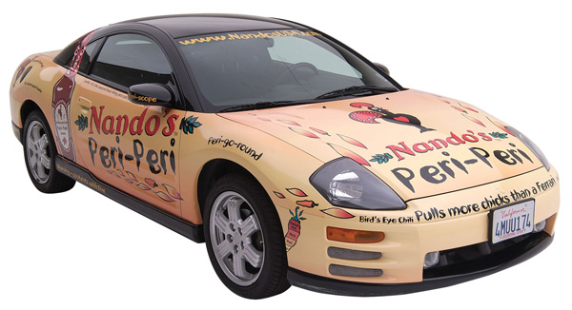

## Competitor Profiles

Company Name: SuperWraps  
Address: 234 West High Street, Austin, Texas 78727  
President: Patrick White  
2008 Sales: $5 million  
Employees: 14  
Founded: 2002

Website: www.superwraps.com

Company Name: Austin Graphics  
Address: 2100 Kramer Lane, Suite 100 Austin, TX 78758-4098  
President: David Pesnell  
2008 Sales: $8 million  
Employees: 13  
Founded: 1996

Website: www.austingraphics.com

Company Name: WrapVehicles.com by Monstermedia  
Address: 1515 Marlborough Ave., Riverside, CA 92507  
President: Eric Hutchinson  
2008 Sales: $8.75 million  
Employees: 15  
Founded: 2000

Website: www.wrapvehicles.com

Company Name: Lucky Luciano Custom Paint  
Address: 2001 W. Cheryl Drive, Suite 3A, Phoenix, AZ 85021  
President: Lawrence “Lucky” Luciano  
2008 Sales: $1.75 million  
Employees: 5  
Founded: 1983

Website: luckylcustoms.com

Company Name: Adwraps Media

Address: 190 Park Ave, Red Bank, NJ, 07701  
President: Jack Johnson  
2008 Sales: $3 million  
Employees: 7  
Founded: 1999

Website: [www.ad-wraps.com](http://www.ad-wraps.com)

Competition Analysis Worksheet



Market Offer Profile

Product/Service

A vehicle wrap is a high quality and high-resolution vinyl covering applied directly over the original paint. When a consumer feels that it is time to remove the vinyl covering, it will peel right off. The paint will remain untouched, in fact, it even helps protect your vehicle the sun and other environmental elements.

A car wrap is a much more economical way to get attention to your brand name. If you have ever seen a vehicle with a wrap on it you will know how attention getting they are, it is almost impossible not to look it over. Once you see the same one a few times you are bound to remember the brand name and maybe even the website address or phone number.

We accept pre-designed orders, or companies can work with our professional staff to create exactly what is desired for their vehicle. We take our work very seriously. Using the proper templates is key to doing effective design so the wrap turns out right. After investing in an auto library, which gives us access to 3-D vector images of cars, trucks, and buses, providing proper dimensions of 95% of all vehicles, our designers utilize software and computers complete the designs for printing.

From there, we ship the vinyl to our customers. While not required, we encourage that most of our customers gain membership to the PDAA. The members of the Professional Decal Application Association understand the properties of adhesive-backed media. Proper installation ensures that the vehicle wrap will last for the entire length of the recommended durability, which is anywhere from 2-4 years.

In addition to utilizing members of the PDAA, we the Automotive Illustrators pride ourselves as members of the SGIA. The Specialty Graphics Imaging Association, mission is to “provide imaging professionals with the tools and information needed to make the best possible business decisions.” Members are also responsible for enhancing or creating value for existing products.

As for our printing technology, we have the latest Industrial grade Epson Stylus Pro GS6000. Epson has maintained a reputation for many years, as a top choice for printing technology. Their latest product allows us print at extremely high resolutions with ink that contains no Volatile Organic Compounds (VOCs). In the past with many printing chemicals, they were unregulated and harmed the environment. We are sure to use the inks that are not only environmentally friendly, but also compliant with 3M standards.

3M is considered the industry leader for vinyl graphics and their recommended processes cannot be beat. Combined with their certification by the PDAA, our clients have always been satisfied with the feedback received by their customers.

Price

Immediate Consumer: The cost to the immediate consumer for only the printed vinyl is consistently 20% - 40% the estimated total price. You add the installation fees. There are a number of variances but we have a financial analysis in the appendix for you to reference to, for sales purposes.

Ultimate consumer: Prices vary depending on the amount of service, installation time, and the vehicle size for each individual customer. However, the typical costs range from about $1,500 to about $5,000 for the ultimate consumer.

Credit: We like to reward our partners. Unlike many competitors, we offer a discount of 2/10, n/30. This gives our clients a chance to have a greater markup on their asking price, and helps to establish a working relationship.

Warranty: On our vinyl, we honor every warranty 3M issues standard through their 3M Scotchprint products. So when necessary, we will contact 3M in order to solve an issue with a vinyl defect.

If there are now defects, you may return your

In the printing process, we have constant communication with our clients and the ultimate consumer to ensure satisfaction. We have a 6-step process to confirm the design before printing.

6-Step Confirmation Process:

|  |  |
| --- | --- |
| **Confirmation Process** | |
| Step 1: | Confirm design with immediate consumer |
| Step 2: | Issue a mock-up/layout to immediate consumer |
| Step 3: | Immediate consumer confirms/makes necessary changes with customer |
| Step 4: | Return a signed copy of the draft to the Automotive Illustrators |
| Step 5: | Draft a contract |
| Step 6: | Sign contract, between 3 parties, and Print |

*see the samples in the appendix

Delivery policy: After a contract has been signed, we will be able to ship within on week depending on current demand. Our delivery policy is Free On Board – Destination. The Automotive Illustrators have full responsibility of the vinyl from the time it leaves our production facility in Franklin, Tennessee, until it arrives at the destination of our immediate consumer. Greater than 95% percent of our deliveries are made on time, and any delivery that arrives late, we offer a discount to the purchaser.

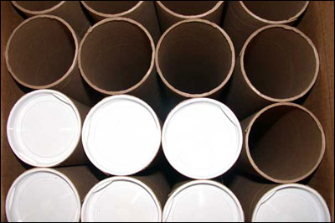

## Promotion

Through our website, we have links to all of the companies that utilize our service. We also have advice for designing a wrap, vehicle selection, a pricing estimator, and contact information where potential dealers can get more information and set up an appointment to meet with a representative.

Our primary market is selling to other businesses. The most successful form of communication thus far in our expansion efforts have been through direct mail and industry magazines. Our campaign is less than a year old, so we are still in the implementation stage. We feel at this point that we have been successful.

In addition to traveling to local auto shows, displaying our product, we also have a website, which offers significant information and allows companies to submit information about further contact from us. (Please see the attachment in the appendix)

Bonus - After an immediate consumer has sold 10 vehicle wraps, we want to reward them with a wrap of their own. The wrap will feature a design highlighting their company name, information, a design, and our logo. While it is not necessary to use the wrap, we want to offer it to them as an incentive, and sales tool to promote their business and our service. If we have more than a week in advance of making a sales call, an effective tool during a presentation is presenting a mock up of a custom vehicle wrap.

Spiff – As an introductory offer to new clients, for the first 6 months, we offer a $50 bonus for every wrap sold to salespeople of his/her company. We have found at the three locations where we are currently doing business outside of Nashville that his has been a highly effective tool.

Promotional Packet – designed for the use by our clients to pass along to their customers

#### Advertising Statistics* - Included inside the brochure

* Prime time TV spot $20.54
* Newspaper (1/4 page BW) 11.66
* Prime time network TV 11.31
* Radio ( :60 morning drive slot) 5.92
* Rotary bulletins (posters) 3.90
* Rotary bulletins (billboards) 1.78
* **Truckside/Carside ad 0.70**
* Cost per Thousand (CPM) Source: Trucking Association & Outdoor Advertising Association of America

Other information we include are statistics on the resale of vehicles, which had been previously wrapped, compared to unwrapped similar make and model cars.

## Placement

The Automotive Illustrators recently opened a new headquarters in Franklin, Tennessee. Our services are utilized by a number of locations in the Greater Nashville Area, a single establishment in both Memphis and Knoxville, and finally one in Birmingham, Alabama.

We will begin to make an annual trip to the Knoxville News Sentinel Auto Show, starting this April at the Knoxville Convention Center. We hope to make many contacts with potential clients from Tennessee, Kentucky, Virginia, the Carolinas, Georgia, and other markets in the Southern United States.

As a member of our sales team, you will be responsible for traveling to different areas searching for potential clients, beyond those who initiate contact through our website.

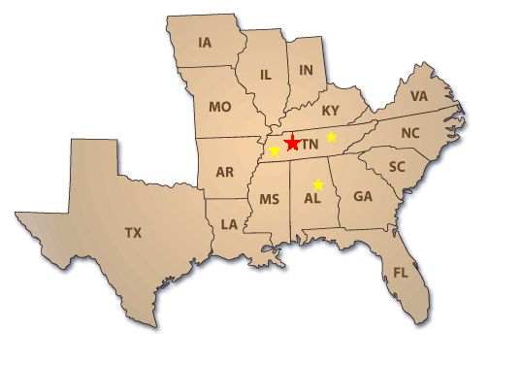

## Description of Features

Below we have a short list of features that apply to our partners and the benefits they receive from their decision to collaborate with us and print automotive vinyl wraps. This will be very important for you, the salesperson to convey to our customers. Further knowledge and explanation will be required, beyond the benefit statements provided.

Immediate Consumer

|  |  |
| --- | --- |
| FEATURES | BENEFITS |
| Low Set Up Costs | We do all the printing for you! |
| Quick Turnaround | After receiving final designs, we can have the vinyl graphics shipped within two days |
| No Annual Contract | We do not contract – we work to offer the best customer service, to satisfy all stakeholders |
| Additional Product to offer | The addition of the product to your offerings give you the opportunity to expand your business and generate more revenue |
| Additional Service (installation) | Using your existing workforce, you are able to charge labor on the installation of the vehicle wraps |
| Visits from the Automotive Illustrators | We will make several visits a year to ensure you and your customers satisfaction. |
| Regional and Limited National Marketing | In our beginning stages of growing the Automotive Illustrators brand, we are looking to increase the amount of advertising we do. Currently we have regional advertisements in trade magazines. |

Below we have a short list of features that apply to our partners’ ultimate consumer and the benefits they receive from their decision to collaborate with them to have automotive vinyl printed and installed on their vehicles. This will be very important for you, the salesperson to convey to our customers. Further knowledge and explanation will be required, beyond the benefit statements provided.

Ultimate Customer

|  |  |
| --- | --- |
| FEATURES | BENEFITS |
| Versatile | Wraps can be created for virtually any vehicle on the road, they can also be changed easily |
| Easy to Apply | Using licensed professionals, a vehicle can be wrapped in less than a day |
| Easy to Remove | If something changes within a clients business strategy, wraps can easily be removed |
| Short Off Road Times | Due to the ease of installation, vehicles are returned to clients quickly |
| Last for Years | The products we use to create automotive wrap are backed by warranties – typically last from 2-4 years |
| Protects Vehicles Finish | When applied over the vehicles finish, the wrap provides UV protection and a barrier against damage caused by loose gravel or road debris |
| Increase the value at time of resale | due to the protection the wrap supplies |
| Design Assistance | If a client has an idea for a design, we offer the ability to partner with our design team to create exactly what they want |
| Offers exclusivity | You don't share space with other advertisers as you would in a promotional mailer or on billboards with ads that rotate |
| Free enterprise | You do not need to outbid competitors to advertise in certain locations |

## Description of Typical Prospects

The following lists are the types of establishments we offer our products for sale. This list is certainly not exhausted, but consists of primary consumers that make up our potential clients. Research of the companies you speak with on sales calls is expected.

### Immediate Consumers

|  |  |
| --- | --- |
| Custom Car Shops | Specializing in automotive graphics, audio and aftermarket customization |
| “Mom-and Pop” Small Printing Establishments | Without increasing their overhead costs, they outsource the printing of automotive vinyl graphics to us, for them to install |
| Large Companies and Retailers | These clients do not consist of a large percentage of our business, but stores like Best Buy, Electronic Stores (with audio installation) offer an opportunity to expand their service offerings |
| Car Dealerships | Large dealers who specialize in working with companies purchasing fleet vehicles |
| Municipalities | The original customers who helped expand the use of vehicle wrap. These groups utilized wraps on public transit busses |
| Race Teams | While they do not sell our product, they use them and have professionals to install the graphics on their vehicles – depending on the size of the teams, they go through both us directly and other printing shops |

### Ultimate Consumers:

Restaurants – for catering services

Small Business – anything from plumbing to computer serving

Fleets – Geek Squad

Airports – busses

Radio Stations

Individual Car owners

Insurance Companies – specific agents – claims vehicles

Promotion Companies

Small Dealerships – courtesy vans

Race Teams

*This list is certainly not exhausted, but these examples are of the any number of clients who may be interested in wrapping a vehicle with The Automotive Illustrators*

## Reasons For Buying

Just a name and phone number painted on the side does not draw much attention any more. If you have a large corporation, you can put wraps on your whole fleet of company vehicles. You may even have big trucks that go across the country; imagine the exposure to your company name if each one was wrapped with an attractive, quality truck wrap.

You can easily change it if something changes in your business; it peels right off so you can change anything anytime you want.

Some statistics to keep in mind from The Traffic Audit Bureau: research puts meaningful numbers behind what consumers have been saying for years:

• 91% of all people notice the words and pictures on cars trucks.

• 75% develop an impression about the company and its products.

• 29% would make a buying decision based on the impression they got from the vehicle.

Maslow’s Hierarchy of Needs

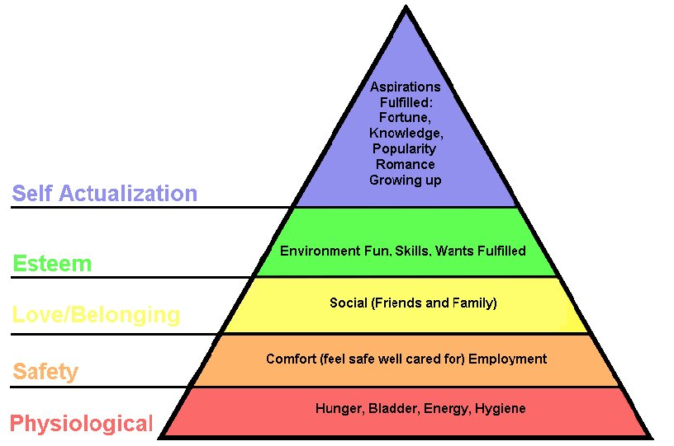

Esteem – Let’s face it, a vehicle with an outstanding wrap will attract attention. Combined with a new car, an owner, whether it is a local restaurant owner, or a high school student, gets a self-esteem boost because of the attention.

Love/Belonging – because finding a place in society to fit, and communicate with others, many drivers of vehicles with vibrant automotive wraps, they find that they are approached much easier, with an obvious topic to talk about, their vehicle. Feedback many people receive in these vehicles is immensely positive.

Safety – As an option, one our products, the reflective vinyl, provides the superior visibility in nighttime conditions. For customers that require them to drive during evening hours, in addition to the cars standard running lights, reflective vinyl is an added benefit.

You will receive business cards, similar to this sample. Cards are typically printed within two weeks of employment with us.



**Jonathan T. Applegate**, President

phone (615) 555-0101 fax (615) 555-0111

4567 Main St., Franklin, TN 37214

[www.TheAutomotiveIllustrators.com](http://www.TheAutomotiveIllustrators.com)

[j-applegate@automotiveillustrator.com](mailto:j-applegate@automotiveillustrator.com)

# PRESALE PLAN

## Prospect Analysis

### What Will You Do

### Once an appointment has been scheduled with a potential client, preparation is the most important part of any sales presentation. Planning is a key. We recommend a daily, weekly, or monthly calendar to keep all of your appointments organized. One resource that may be available to you, when researching, is the form that is submitted to us through our website. However, times may exist where you will have to resort to the internet to research the potential client or even calling them directly. This sales manual has many useful tools, like the Description of Features section, to refer.

If you have the opportunity to speak with this person for a second time, try to bring up your previous experience with this person. It may help you to keep a journal or a spreadsheet on a computer, profiling the various individuals you speak too.

In the following section, using the hints of the Social Style Matrix, you often have the ability to pick up clues that will tell you successful communication techniques that may enhance the likelihood of a sale.

### What Will You Say

When entering into the selling situation, as explained in the dress policy, look professional, and we encourage the GNAP style of greeting, however, we encourage you to use your own personal style, rather than to seemingly offer a canned or robot type of persona.

When offering a firm handshake, the GNAP style refers to the greeting style.

G – Greeting – Such as: Hello.

N – Name – Such as: My name is Jonathan Applegate.

A – Association – Such as: I am with the Automotive Illustrators,

P – Place – Such as: based in Nashville, or Middle Tennessee.

Before mentioning important subjects such as the features and benefits of our vinyl wrap, be sure to listen to the client about their needs. Determine what they are looking for. You will find the more listening you are able to do in the beginning, the better you will understand the important points the client that should be mentioned.

If you find that the client has questions about something that you are going to mention, however, they are ahead of when you typically say them, you have two options: First, explain the information that they want right then, or, second, let them know that you will get to that information in the following part of the presentation.

### Social Style Matrix

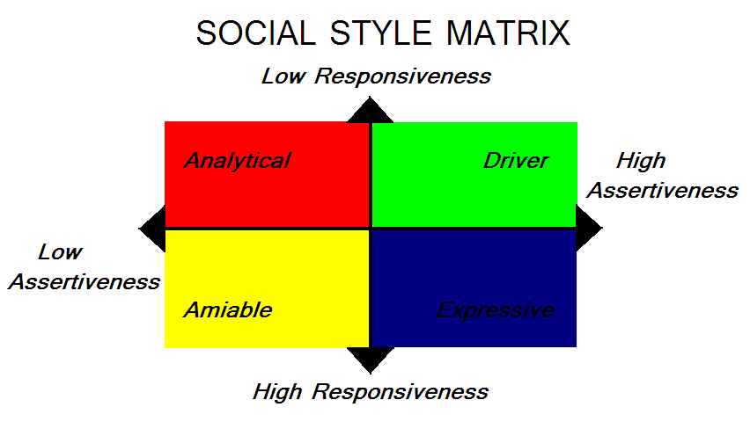

In the determination of how to approach various individuals, we use the Social Style Matrix as an aid.

The following section will indicate the appeals to these individuals, which you will identify. After identification, you will use techniques targeted specifically for them in your approach in order to help communicate your message, ultimately getting the sale.

Hints to Identify Specific Social Styles:

Drivers – Poses technical backgrounds, many awards on the wall, conservative dress, typically speak across the desk

How to Approach: Drivers can be very efficient decision makers and will prefer to get the task at hand, accomplished. They will put their best foot forward to advance their company. (Our products allow many companies to do so!) Do not spend as much time trying to relay technical information, give them the bottom line. Remember to be direct, and emphasize the effect our product will have on profits.

Expressive – Often times, motivational posters are visible, open atmosphere in the office, cluttered desk, casual dress.

How to Approach: Expressive individuals enjoy establishing relationships with those who help meet goals. Their decisions are based upon what is right, for the future of the company. Spending time demonstrating products, interaction, and testimonials may prove to be effective tools to communicate with these individuals. Expressive individuals love personal recognition.

Amiable – will have family photos on display, personal keepsakes around the office, and a liberal arts background

How to Approach: With an amiable individual, personal relationships are important, be sure to spend time getting to know the person. They will be slow to make decisions, being sure to incorporate the input of others. Amiable individuals tend to take fewer risks, and you need to be sure to stress the effects of employee satisfaction.

Analytical – technical backgrounds, office is not cluttered, but has evidence of significant activity

How to Approach: Be sure to present facts and use logic when presenting to an analytical type. Be patient with these individuals because they want to be sure to make the best decision. Present the history of our product and its evolution, because they like to look the history to determine their opinion. Once their decision has been made, they tend to remain loyal. Well-structured presentations are necessary.

## The Sale Presentation

### Sample Questions which Help in Identifying Needs of Customer

1. **Do you have any vinyl products that you sell?**
2. **What has your previous experience like with a vinyl provider?**
3. **What types to do have? (ex. Window decals, stripes, etc.)**
4. **Are you satisfied with these current products?**
5. **Are you interested in expanding your offering?**
6. **Do you have the capital required to expand, on your own?**
7. **Are your installers certified by the Professional Decal Application Association?**
8. **Does your company have a specific margin or ROI that you look for in a new product?**

### Major Appeals

|  |  |
| --- | --- |
| APPEAL | REASON |
| Versatile | Wraps can be created for virtually any vehicle on the road, they can also be changed easily |
| Easy to Apply | Using licensed professionals, a vehicle can be wrapped in less than a day |
| Easy to Remove | If something changes within a clients business strategy, wraps can easily be removed |
| Short Off Road Times | Due to the ease of installation, vehicles are returned to clients quickly |
| Last for Years | The products we use to create automotive wrap are backed by warranties – typically last from 2-4 years |
| Protects Vehicles Finish | When applied over the vehicles finish, the wrap provides UV protection and a barrier against damage caused by loose gravel or road debris |
| Increase the value at time of resale | due to the protection the wrap supplies |
| Design Assistance | If a client has an idea for a design, we offer the ability to partner with our design team to create exactly what they want |
| Offers exclusivity | You don't share space with other advertisers as you would in a promotional mailer or on billboards with ads that rotate |
| Free enterprise | You do not need to outbid competitors to advertise in certain locations |
| SALE BONUS | After 10 wraps sold, the company receives one for their vehicle |
| Quality product | 3M makes great vinyl products |
| Epson Printers | High quality and state-of-the-art |

### Outline of Sales Presentation

1. Established good social and business contact
   1. Handshake
   2. Social Discussion
      1. Apply the social style matrix if possible – when entering conversation
         1. This is the time to ask basic questions about the potential customers business. Ex.
            1. How long has your business been around?
            2. Where do you see your company headed in the future?
2. Transformed to product discussion effectively
   1. I hope to help you meet some of those goals here in the short term.
   2. What all do you remember about us from the expo?
      1. I’ll give history
3. Determined the prospect’s needs (see the section on potential questions to determine needs)
   1. Sample Questions for a small custom car shop
      1. Do you have any vinyl products that you sell?
      2. What has your previous experience like with a vinyl provider?
      3. What types to do have? (ex. Window decals, stripes, etc.)
      4. Are you satisfied with these current products?
      5. Are you interested in expanding your offering?
      6. Do you have the capital required to expand, on your own?
      7. Are your installers certified by the Professional Decal Application Association?
      8. Does your company have a specific margin or ROI that you look for in a new product?
4. Discussion of product features (immediate consumer)
   1. Go through Marketing Mix
      1. Products
      2. Products Service
      3. Promotion
      4. Placement
      5. Price
5. Discussion of product features (ultimate consumer)
   1. See the Description of Features Section
6. Conversion of features to buyer benefits (immediate consumer)
   1. See the Description of Features Section
7. Conversion of features to buyer benefits (ultimate consumer)
   1. See the Description of Features Section
8. Demonstrated the product
   1. See the FOLLOWING SECTION
9. Used sales aid effectively
   1. This is where you would include the PowerPoint Slides
   2. Explain the basics of the vinyl process
   3. Also, use the vinyl samples
10. Handling of competition
    1. Not available within reasonable distance, we are able to provide superior customer service to you
11. Negotiation and persuasion abilities
    1. Explain the offer for getting employees to receive PDAA certification
    2. Wrap a vehicle; after 10 are sold – show a sample of what your vehicle will look like!
    3. Explain spiff promotion
       1. REMINDER!!! – SPIFF - $50 dollars per wrap per sales person
12. Overcame sales resistance effectively
13. Closed the sale effectively
    1. Asking if there are any other questions
    2. Training session
    3. Date that will work

## The Sales Demonstration

### Demonstration Analysis Form

|  |  |
| --- | --- |
| Demonstration Tool | Benefit |
| PowerPoint | We have a PowerPoint we like to use to show the variety of vehicles we have previously wrapped. This helps instill the confidence that we can provide quality wrap for any vehicle on the road. |
| Vinyl samples we show | To appeal to the sense of touch, feeling the vinyl helps to actually see the quality of 3M Scotchprint materials – Below we have a description of the 3 most common types of vinyl we use. If enough time is provided in advance of certain presentations, we can obtain other appropriate samples. |
| Testimonials | Below we have a couple testimonies provided by Ultimate consumers who have been in contact with our product. |
| Company Vehicle | While not always available, when possible, we encourage traveling by one of our company vehicles. This not only helps promote our product on the way to the sales pitch, but also as a tool to use as an explanation to our clients. |

### Selling aids you will use

PowerPoint Slides – Please see the appendix with the sample PowerPoint Presentation. This is an effective selling aid that may be used during a presentation. It is difficult to have live samples of our work going to a selling environment for the first time. While we often drive vehicles that have been wrapped by ourselves, it is not always guaranteed that we will have a vehicle. Seeing these slides give potential partners an idea of the quality work we can produce.

Testimonials:

Dear Automotive Illustrators,

My name is Vince, and my family and I have been racing dirt late models for the last 10 years. We have been around the block so to speak when it comes to preparation of our machines. I have to say that we have been very satisfied with the quality of the vinyl you provide. While we typically purchase new vinyl graphics every spring, we have been able to keep our latest version for the past year and a half. After every heat, we are able to clean the car up and it looks brand new every time.

Thanks for such a great product,

Vince Parker, of Vince Parker Racing

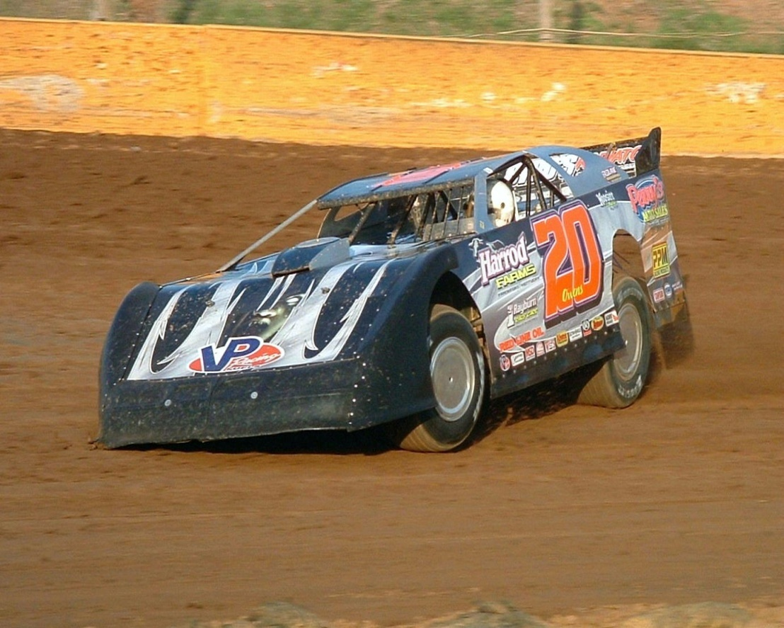

Vince Parker’s Automotive Illustrator Wrapped Late Model

To Whom it May Concern:

Greetings! My name is Richard Gordon, and I cannot positively express what wrapping my delivery van has done for my business, other than saying “WOW!” I own a chain of 3 small Mexican restaurants in the Memphis area. Six Months ago, we searched for a vinyl provider to wrap our vehicle, and the shop that installed our wrap referred us to you!

Not only were their installers talented and professional, our 2 delivery vans look phenomenal. We’ve taken out ads in local papers, put coupons in local coupon books, but nothing has increased the awareness of our locations than the vans. The prices were very reasonable, especially seeing the positive response we have got! I just had to write a quick note to say thank you. The next vehicle that we wrap, it will be an AUTOMOTIVE ILLUSTRATOR wrap!

Thanks,

Richard Gordon, owner, Burrito King  
 Memphis, TN

Vinyl Samples we show

Type 1: reflective vinyl – A great built in safety feature for clients that do a lot of driving during the nighttime hours. This vinyl is still highly visible during the day. This vinyl can be applied to simple designs, like names and telephone number to an entire vehicle for a unique, stand-alone vehicle.

Type 2: Window Vinyl – Unlike window tint, this can be applied over the window surface

Type 3: Standard 3M vinyl, try to stretch, heat is used to remove memory

Handling sales resistance

Anticipated sales resistance

As a professional, and a salesperson, objections are expected. Not everyone can afford to say yes! With the Automotive Illustrators, we demand that you DO NOT TAKE IT PERSONAL. There is a difference between an ineffective salesperson, and a client who cannot afford our partnership product. We have invested in you, and we believe that you are a quality employee. Therefore, we have faith in you. Below, we have offered up some common objectives, you should read these, be aware, and even add some of your own. Also, have responses prepared for each of these.

Common Objective Statements

|  |  |
| --- | --- |
| Objection | Response |
| *Immediate Consumer*: I am content with my current supplier. | That is great that you are currently content. If you are only content, is there any way we could service you better? I would love a chance to tell you about how we differentiate our services from our competitors |
| *Immediate Consumer*: I do not want to commit to a long term contract. | We do not have any long-term contracts. You contact us and we print. Simple as that! |
| *Immediate Consumer*: I would rather paint cars than wrap them in vinyl. | That’s fine, but vinyl opens up the customization options, and includes many customers with smaller budgets with the same if not greater benefits |
| *Immediate Consumer*: As a buyer, I have to pay upfront for the printing. | False. We have flexible payment options, including a discount of 2/10, n/30. In addition, we want our partnership to work! We’ll work with you to meet payments if any unforeseen circumstances arise |

Some information we also provide our clients are ways to handle their clients, as well. Below we have a few objections that are often raised, and responses on how we might approach the situation. Of course, we do not know everything about their company, and in no way want to tell them how to run their business. We just want to offer them an alternative.

*Negotiation and or visual support tools*

Common Resisting Statements from Ultimate Consumers

|  |  |
| --- | --- |
| Objection | Response |
| *Ultimate Customer*: An upfront investment of hundreds to thousands of dollars are required | The payment from the ultimate consumers is up to you, and what will work best. |
| *Ultimate Consumer*: I drive the same routes every day; I am going to advertise to the same people | That actually helps build brand awareness. If you refer to the promotional packet, which you will receive, |
| *Ultimate Consumer*: It is difficult to track ad results | Again, these estimates will be included in the promotional packet. |
| *Ultimate Consumers*: I have to stay local because outside of a certain area, my design will lose effectiveness | It increases awareness through the attractive design. Website and phone number placement is important. |
| *Ultimate Consumer*: My car will be off the road for an extended period of time, what will happen when I need it? | This is not true, once the vinyl has been received and an appointment has been scheduled, a vehicle can be back on the road within 24-72 hours. |

Closing the sale

Closing Cues

Some of these following hints will give you an opportunity for a trial close. If successful, we recommend that you move in to a final close.

**Direct Request** Ask for a specific answer, “Would you like to become an Automotive Illustrator Partner?” or “Can I come back sometime next week to go over the ordering process with you and your employees?”

**Benefit Summary** After going through the process and demonstrating the benefits to the customer, the salesperson shall remind the person how the product meets their needs and will satisfy their customers. Perhaps even writing them out as they go through the presentation will be an effective way to closing the sale.

**Balance Sheet Method** By comparing, side-by-side, two competitors, this method will provide a visual for the buyer to see which company provides more need-satisfying benefits over the other. Using a matrix of this style may help the hesitant buyers make a decision.

**Probing Method** Often times, buyers have a real reason for rejection that they are trying to hide. If the objection seems to be based upon fallacy, a series of questions may be appropriate, when sleuthing for the truth.

**Continuous Yes** When you are hearing the word, “Yes,” throughout the sale, the buyer is at least agreeing with what you are saying. This is a positive. When reaching the end of the sale, a question such as, “By, yes, do you mean you are interested in offering The Automotive Illustrator service?,” may be appropriate.

**Trial Order -** We would go ahead and collaborate with a company for a short period, to try out our service to see if it will be worthwhile. There will be an option to continue after the trial period concludes.

Servicing the sale

Additional items

While most custom car shops and other establishments that specialize in the installation of vinyl. Offering the removal can be just as important. Because wrapping a vehicle an serve as a protective layer from Ultraviolet rays and typically road scratches on the finish, removal is just as important to keeping the value of the finish. There are a number of products available to use, however the one we recommend is called Vinyl-Off. A link to their website can be found here: <http://www.westendproducts.com/vinyloff.htm>.

### Additional Assistance

Because receiving the certification by the Professional Decal Application Association is important to us, we will assist in the process of getting client’s employees certified. While there are local branches, and sometimes multiple branches within each state, we will cover the travel expenses and one-day’s worth of lost wage to go through the certification. While it is a three-day process, two of those days are to be completed on the employees own time. Showing that commitment, allows us to invest in their certification on the third and final day. It is on the third day where they actually receive practice and instruction on how certified installers perform their duties.

Courtesy Contact

There will be several visits conducted each year by, you, the salesperson, checking up with current clients, in order to ensure satisfaction for all parties involved. The key to our relationship is that they are all mutually beneficial. Checking in with them lets them know that we care, and gives them an opportunity for face-to-face contact and provide us any feedback that is necessary.

## Long-term partnering plan

While this was also mentioned, under or Promotion section, one of our long-term goals, is after we have sold 10 wraps, we will print a wrap, free, to our clients. This is to be used as a tool to promote their business, and as a sample for the quality vinyl, we provide to them. It is also highly encourage that it is shown to customers to give them an idea of the product they might be interested in.

We hope that our relationships are mutually beneficial. We are confident in our strategy because we do not work through long-term contracts. Our hope is that if there are any issues, effective communication efforts by both parties ensue to make sure everyone is satisfied.

## Territory management plan

At the Automotive Illustrators, we have instituted a computerized planner, that allows us to utilize our sales force while putting as little stress on them as possible. We ask them to be out of the office and on the road; however, we do our best to keep it at a minimum. Two to three days a week are the maximum.

# Glossary

Automobile – typically meaning small vehicles, we use these terms to include all types of vehicles, from small Mini Coopers to Large Tour Buses – we can print wraps for anything on the road

Illustrator – How we refer to all employees of the Automotive Illustrators

Immediate Consumer – The client that a salesperson is selling to

Partner – How we refer to companies, we partner with to print automotive vinyl wrap

Ultimate Consumer – Who our immediate consumer is responsible for selling to

Wrap – The printed vinyl that is applied to vehicles to add designs or promote branding efforts, etc.

# Appendix

The Following is an example of the confirmation process when printing for a customer

**Step 1:**

Confirm the design, with You, immediate consumer and ourselves.

Need to know:

Car Model, Make and Year

Design – Any design assistance takes place here

**Step 2:**

We will issue a mock up of the potential design – fax or email in return

*this layout is for a late model stock car

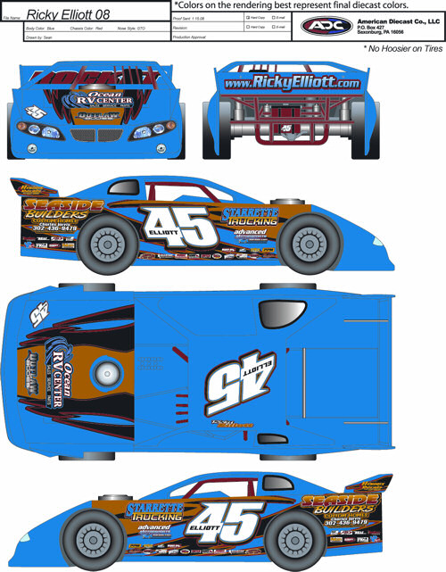

**Step 3**

Make Changes to mock up

**Step 4:**

Return Signed contract

**Step 5**

Draft Contract

**Client Name:** [Your client's name] (hereinafter referred to as "Client")

**Contractor Name**: [Your name] (hereinafter referred to as "Contractor")

**Rates:** Contractor shall bill Client at the following hourly rates: [$30] for word processing, time-and-a-half [$45] for rush, weekend, or evening work; [$15.00]/hr. travel time. Contractor shall bill Client at the following piece rate: [$.50]/pg. for printing, [$.25] per 3-line label for data entry. [Include all applicable prices].

**Appointments:** Client shall deliver and pick up work by appointment only. Client shall pay a fee of $20.00 for missed appointments (including over 1/2 hr. late) unless Contractor is notified at least 1 hr. prior to the appointment.

**Consultation:** Time spent conferring about Client's project shall be billed at the hourly rate of [$30].

**Charges & Payment:** Work shall be estimated according to the Industry Production Standards established and published by the Association of Business Support Services International and billed at the rates described above. Because of the varying nature and unpredictability of different projects, it is not possible to give formal estimates. Payment is due when Client picks up the work, whether in draft or final form. Payment for first time customers should be made in cash unless otherwise arranged. A fee of up to $100 may be charged for any returned check. Work shall be retained by Contractor until payment is received. A deposit equal to four hours ([$120]) is required for all jobs likely to exceed that time. If Contractor is required to work at Client's office, Client shall pay four hours minimum.

In the event of changes to the scope of work or other factors outside of Contractor's control, Contractor shall reserve the right to renegotiate this Agreement and collect for all services performed up to the date of renegotiation.

**Termination:** Either party may terminate this Agreement by giving written notice to the other party. In the event of termination, Client shall pay Contractor for all hours and expenses accrued up to the date of termination. In the unlikely event litigation is commenced between the parties of this Agreement, the party prevailing shall be entitled, in addition to other relief, to a reasonable sum for attorney's fees.

**Approved:**

________________________   _________  
Contractor                               Date

________________________   _________  
Client Name & Title                  Date

**Step 6:**

We Print

The following form is what is available on our website. Please be familiar with this. You will be using this as a starting point for research when looking to speak with new potential clients.

**PARTNER APPLICATION**

The Automotive Illustrators provide the highest quality Automotive Vinyl Wrap. If your company is interested in becoming a partner who we print vinyl for, please provide the following information, and one of our Illustrators will be in contact within one week of receiving this completed form.

**PERSONAL INFORMATION**

Name _____________________________________

City ______________________________________________ State __________ Zip code_____________

Phone: Home ______________________ Work ____________________ Cell ______________________

E-mail address ________________________________________________

**EDUCATION**

Undergraduate college ________________________________

Graduation year and major field of study ______________________

Graduate college(s) and degree(s) received ________________________________________________________________________

If you did not graduate from college, indicate last grade completed. ____________________________________________________

**How did you hear about The Automotive Illustrators?**

Trade Magazine Yes _____ No _____

Automotive Magazine Yes _____ No _____

Newspaper Yes _____ No _____

Trade Show Yes _____ No _____

Website Yes _____ No _____

Other Yes _____ No _____

Please specify specifically which publication if applicable _______________________

**BUSINESS**

Company Name: ____________________________ ____________________________________________________________________________________

Address ____________________________________________________________________________________

Position ____________________________________________________________________________________

Describe duties. _____________________________________________________________________________________

Contact person and phone number ______________________________________________________________________________

Please explain the types of products and services your company offers. ____________________________________________________________________________________________________________________________________________________________________________________________________________________________________________________________________________________________________________________________________________________

**REFERENCES**

Please list personal and business references (other than employer, employees, family or other members of your investment group).

Name in full________________________________________________

Phone ____________________________________________

Occupation ________________________________________________

Relationship/years known ____________________________

Name in full________________________________________________

Phone ____________________________________________

Occupation ________________________________________________

Relationship/years known ____________________________

**CONFIDENTIAL**

The information that is given in this form will be regarded as confidential and only used to help The Automotive Illustrators move forward in the partnering process. Just as it is important for use to learn as much as we can about you, it is important for you know about us. Call our corporate office at (615) 555-5231. Based on the information in this application, we will Review the information, and have someone in contact with you in the next 7 Days.

_________________________________________________________

Name of Owner completing this application

_________________________________________________________

Signature Date

Please send completed Form to:

The Automotive Illustrators

Attn: Sharon Hufford

4567 Main Street

Franklin, TN 37214

On the subsequent pages, are PowerPoint Slides used in the presentation.

*Please note that these are constantly changing with new wraps that are produced.